EV CHARGING ANALYTICS
User Guide
Dashboard: EV Charging Analytics
Purpose: Monitoring Renewable Integration, Energy Demand and Dynamic Pricing Performance
Data Coverage: January 2025 – March 2025

1. Introduction
The EV Charging Analytics dashboard is an interactive Power BI analytics application designed to monitor electric vehicle charging activity and operational performance.
The dashboard helps users analyze:
- Charging demand and charging sessions
- Energy consumption
- Charging duration
- Waiting time
- Charging cost
- Vehicle performance
- Charger performance
- Charging station performance
- Location-level demand
- Vehicle-type behavior
The dashboard is designed with interactive navigation, filters, tooltips, drill-through analysis, bookmarks, user information, RLS indicators, and operational notifications.

2. Opening the Dashboard
Step 1 — Sign in
Open the Power BI report shared with you.
Sign in using the Microsoft/organizational account that has been granted access to the report.
If your organization has provided access through your business email, use that account when prompted.
Step 2 — Open the Report
After signing in:
- Open the Power BI workspace or shared report.
- Select EV Charging Analytics.
- Wait for the dashboard to load.
- The dashboard opens on the Executive Overview.
Access to the report depends on the permissions assigned by the report administrator.

3. Understanding the Dashboard Layout
The dashboard contains four main analytical sections.
Main Sections
- Executive Overview
- Charging Analysis
- Vehicle Analysis
- Station & Location Analysis
These sections can be accessed using the navigation icons on the left side of the dashboard.
The left navigation bar contains icons representing the different analytical views.

Executive Overview

Charging Analysis

Vehicle Analysis

Station & Location Analysis

4. Executive Overview
The Executive Overview is the main landing view.
It provides a high-level summary of the EV charging network.
Main Sections

The page contains six KPI cards and several analytical charts.
Six KPI Cards

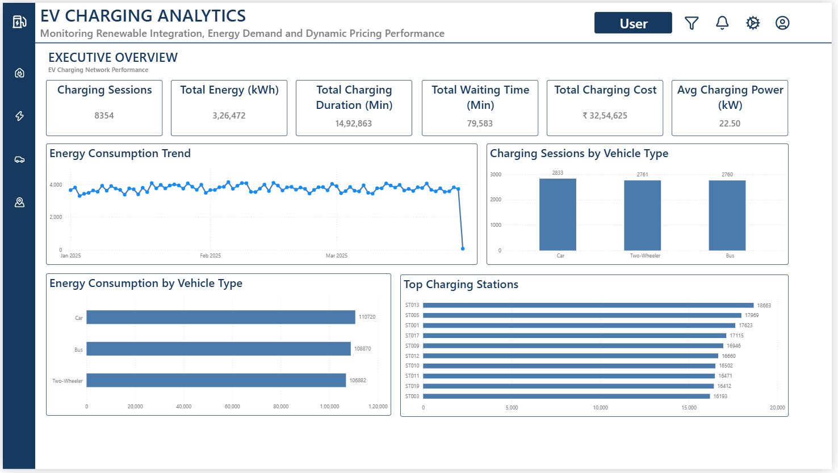
4.1 KPI Cards
The six KPI cards are:
Charging Sessions
Shows the total number of charging sessions in the currently selected filter context.
Total Energy (kWh)
Shows the total energy consumed during charging sessions.
Total Charging Duration (Min)
Shows the combined charging duration across the selected data.
Total Waiting Time (Min)
Shows the total waiting time recorded across charging sessions.
Total Charging Cost
Shows the total charging cost.
Avg Charging Power (kW)
Shows the average charging power.
These KPIs automatically respond to the report filters.

5. Executive Overview Charts
5.1 Energy Consumption Trend
This line chart shows energy consumption over time.
How to use it
- Move the mouse over a point on the line.
- A tooltip appears.
- The tooltip provides additional information
for the selected date/context.
The chart can be used to identify:
- High-energy periods
- Low-energy periods
- Changes in charging demand
- Overall energy consumption patterns.
5.2 Charging Sessions by Vehicle Type
This chart compares charging sessions between
vehicle categories.
The available vehicle categories include:
- Car

- Two-Wheeler
- Bus
Use this chart to understand which vehicle types
contribute most to charging activity.
- Car — 2,833 sessions
- Two-Wheeler — 2,761 sessions
- Bus — 2,760 sessions

5.3 Energy Consumption by Vehicle Type
1. This chart compares total energy consumption
across vehicle types.
2. It helps identify which vehicle category consumes
the greatest amount of charging energy.

- Car — 110,720 kWh
- Two-Wheeler — 106,882 kWh
- Bus — 108,870 kWh

5.4 Top Charging Stations
1. This chart ranks charging stations according
to their charging activity/energy performance.
2. Users can identify high-performing or
high-demand stations.
3. This visual also supports the Station Details tooltip
and can be used as a starting point for station-level
drill-through analysis.

6. Using the Filter Panel
The dashboard contains a dedicated filter panel.
Click the Filter/Funnel icon in the top-right area.
The filter panel contains:
Date
Allows the user to select a date range.
The current dataset covers:
January 1, 2025 – March 29, 2025
Vehicle
Allows filtering by vehicle type.
Examples:
- Car
- Two-Wheeler
- Bus
Location
Allows filtering by location type.
Examples include:
- Urban
- Highway

7. Applying Filters
To apply a filter:
- Click the Filter icon.
- Select the required Date range.
- Select a Vehicle type if required.
- Select a Location type if required.
- Close the filter panel.
The selected filters affect the analytical visuals and KPI values throughout the report.
For example:
Vehicle = Car
will update the dashboard to show information associated with the selected vehicle type.

8. Resetting Filters
1. If filters have been applied and you want to
return to the default dashboard state:
- Open Settings.
- Select Reset Filters.
2. Alternatively, use the Reset Filters option
available inside the filter/settings workflow.
3. The dashboard returns to its default filter context.

9. Charging Analysis
Click the Charging/Lightning icon on the left navigation bar.
This opens the Charging Analysis view.
This section focuses on charger utilization, charging demand, and operational performance.

9.1 Charging Mix by Charger Power (kW)
This donut chart shows the distribution of charging sessions across different charger power levels.
Use it to understand the charging-power mix within the network.
Hover over a segment to inspect its value.

9.2 Charging Demand Pattern
This area chart displays charging session demand over time.
It helps identify:
- Demand patterns
- High-demand periods
- Low-demand periods
- Changes in charging activity

9.3 Charging Activity vs Energy Consumption
This combined chart compares:
- Total charging sessions
- Total energy consumption
It allows users to compare charging activity against the amount of energy consumed.

9.4 Charging Performance by Charger ID
This chart ranks chargers based on total energy performance.
The charger IDs can be used to identify high-performing chargers.
This visual is also important for Charger Drill-through.

9.5 Station Charging Operations
The table provides station-level operational information.
The table contains information such as:
- Station ID
- Total Sessions
- Total Energy
- Charging Duration
- Waiting Time
- Total Charging Cost
Users can scroll through the table to inspect individual stations.

10. Vehicle Analysis
1. Click the Vehicle icon on the left navigation bar.
2. This opens the Vehicle Analysis section.
3. This page focuses on vehicle charging behavior and
energy consumption.

10.1 Charging Sessions by Vehicle Type
The chart displays the distribution of charging sessions across:
- Car - 33.91%
- Two-Wheeler – 33.04%
- Bus – 33.05%
It provides a quick comparison of vehicle demand.

10.2 Vehicle Energy & Charging Duration
This scatter chart compares:
- Charging duration
- Energy consumption
- Vehicle type
- Charging session volume
The size of the data point represents charging-session activity.
Use this visual to identify relationships between charging
duration and energy consumption.

10.3 Energy Consumption by Vehicle Type
1. This chart shows energy consumption by
vehicle type across different months.
2. It can be used to compare monthly energy
consumption between:
- Car
- Bus
- Two-Wheeler

10.4 Vehicle Demand Ranking Over Time
1. This visual shows how vehicle-type demand changes over time.
2. It helps users understand changes in vehicle demand between different months.

10.5 Vehicle Performance Details
The table provides vehicle-level information.
The table includes:
- Vehicle ID
- Total Sessions
- Total Energy
- Charging Duration
- Waiting Time
- Total Charging Cost
This table is the primary
starting point for Vehicle Drill-through.

11. Station & Location Analysis
1. Click the Location/Map icon on the left navigation bar.
2. This opens the Station & Location Analysis section.
3. This page focuses on station utilization and
geographical/location-level performance.

11.1 Location Energy Share
1. This gauge shows the energy contribution associated
with the selected location context.
2. It provides an overview of location-level
energy distribution.

11.2 Charging Sessions by Location Type
1. This donut chart compares charging sessions by
location type.
For example:
- Urban
- Highway

2. It helps identify where charging activity
is concentrated.

11.3 Top Charging Stations by Energy
1. This horizontal bar chart ranks charging
stations according to total energy consumption.
2. Use it to identify stations with the highest
energy demand.

11.4 Energy Demand by Location Type
1. The treemap compares energy demand
between location types.
2. Larger areas represent greater energy demand.

- Urban – 1,63,680
- Highway – 1,62,792

11.5 Station Performance
1. The station performance table provides
detailed station-level information.
2. It contains:
- Station ID
- Total Sessions
- Total Energy
- Charging Duration
- Waiting Time
- Total Charging Cost

12. Interactive Tooltips
The dashboard contains four dedicated tooltip pages.
These tooltip pages are hidden from normal report navigation and appear automatically when the user hovers over specific visuals.
The tooltip pages are:
- TT_EV KPI SUMMERY
- TT_ENERGY TREND
- TT_VEHICLE SESSIONS
- TT_STATION DETAILS

13. KPI Tooltip
The KPI tooltip is available when hovering over the six Executive Overview KPI cards.
The tooltip provides contextual KPI information including:
- Charging Sessions
- Total Energy (kWh)
- Total Charging Duration (Min)
- Total Waiting Time (Min)
- Total Charging Cost
- Avg Charging Power (kW)
How to use
- Go to Executive Overview.
- Move the mouse over any KPI card.
- Wait for the tooltip to appear.
- Review the additional KPI information.
- Move the mouse away to close it.
The tooltip reflects the current filter context.

14. Drill-through Analysis
The report contains three dedicated drill-through pages.
Drill-through pages
- DT_CHARGING ANALYSIS
- DT_VEHICLE DETAILS
- DT_STATION DETAILS
These pages are hidden from the normal navigation and are accessed through drill-through actions.

15. Returning from Drill-through
1. Every drill-through page contains a Back button.
2. After completing the detailed analysis:
- Click the Back button.
- Power BI returns to the previous report view.

16. Notifications
The dashboard contains a notification panel accessed using the Bell icon.
The current notification panel is static.
It contains:
HIGH CHARGING
Station ST013
LONG WAITING
Station ST005
NETWORK STATUS
Operating normally

18. Settings Panel
Click the Settings/Gear icon to open the Settings panel.
The panel contains:
Executive View
Returns the dashboard to the Executive Overview.
Detailed View
Opens the detailed Charging Analysis view.
Reset Filters
Returns the dashboard to the default filter state.
About This Dashboard
Opens information about the purpose and coverage of the dashboard.

19. About This Dashboard
The About panel explains the dashboard.
Purpose
Analyze:
- Charging demand
- Energy consumption
- Operational efficiency
- Network performance
Data Coverage
January 2025 – March 2025
Key Analysis Areas
- Charging Demand & Sessions
- Energy Consumption
- Charging & Waiting Duration
- Charging Cost
- Vehicle Performance
Users can close the panel using the X/Close icon.

20. User Profile
Click the User/Profile icon in the top-right corner.
The User Profile panel displays information such as:
- Current User Email
- Current User Role
- Current User Access
- RLS Status
The panel confirms whether Row-Level Security (RLS),
is enabled for the current user.

21. Row-Level Security (RLS)
The dashboard uses RLS to control what data a user can access.
The User Profile panel provides an indication of the current user's security context.
For example, an administrator may see:
Role: Admin, Manager 1, Manager2
Access: All Locations, (1,2,3), (4,5,6)
RLS: Enabled
A normal user may see a different role and a restricted location/data scope depending on the security configuration.

*** continue to next page for Complete Dashboard Usage Flow ***
